Task 4
By: Jorge Luna y Martin
Theory
- What is Data Augmentation?
Deep learning models for Image Classifications often needs a lot of data to be able to see the paterns to identify things in a image. Finding data for your objective might be hard, which means at the end you do not have that much data to train your model correctly. For this problem we use data augmentation, which transforms the data that you already have to create more data to train your model. If use effectively, we can get 10 or 100 times larger data sets [1].
- Why does training on a limited dataset lead to overfitting, and how does augmentation help address this?
A model has thousands to millions of learnable weights. With a small dataset, there are far fewer training examples than there are degrees of freedom in the model. The model can "solve" the training set perfectly by memorising every example — which specific pixels looked a certain way in image #7, for instance — rather than learning the general rule of what dense vegetation looks like. This is overfitting: the model fits the training data so precisely that it fails on anything new.
Augmentation helps by making memorisation impossible. If every time the model sees image #7 it has been randomly flipped, rotated, brightened, or cropped slightly differently, the model can never memorise the exact pixel arrangement. The only consistent signal across all those variations is the underlying structure — the actual shapes, textures, and patterns of vegetation — which forces the model to learn that instead. Effectively, augmentation makes a dataset of N images behave like a much larger one by ensuring the model never sees the exact same input twice.
- What types of transformations are most commonly applied to image data, and when is each appropriate?
- Rotation – rotate the image by a random number of degrees.
- Brightness – randomly offset the exposure of the image.
- Flip – do a vertical or horizontal flip to a image
- Scaling – resize images to different dimensions, for example, zooming in/out.
- How does augmentation interact with label structure, particularly for pixel level prediction tasks?
When we go into pixel level, we called it semantic segmentation (one label per pixel), the label is a spatial map that must stay geometrically aligned with the image. If you rotate the image 30°, every pixel moves to a new position, so the label mask must rotate by exactly the same 30° or the class assignments point at the wrong pixels.
Implementation
Using a dictionary as a global configuration, we stablish the probability to apply the changes.
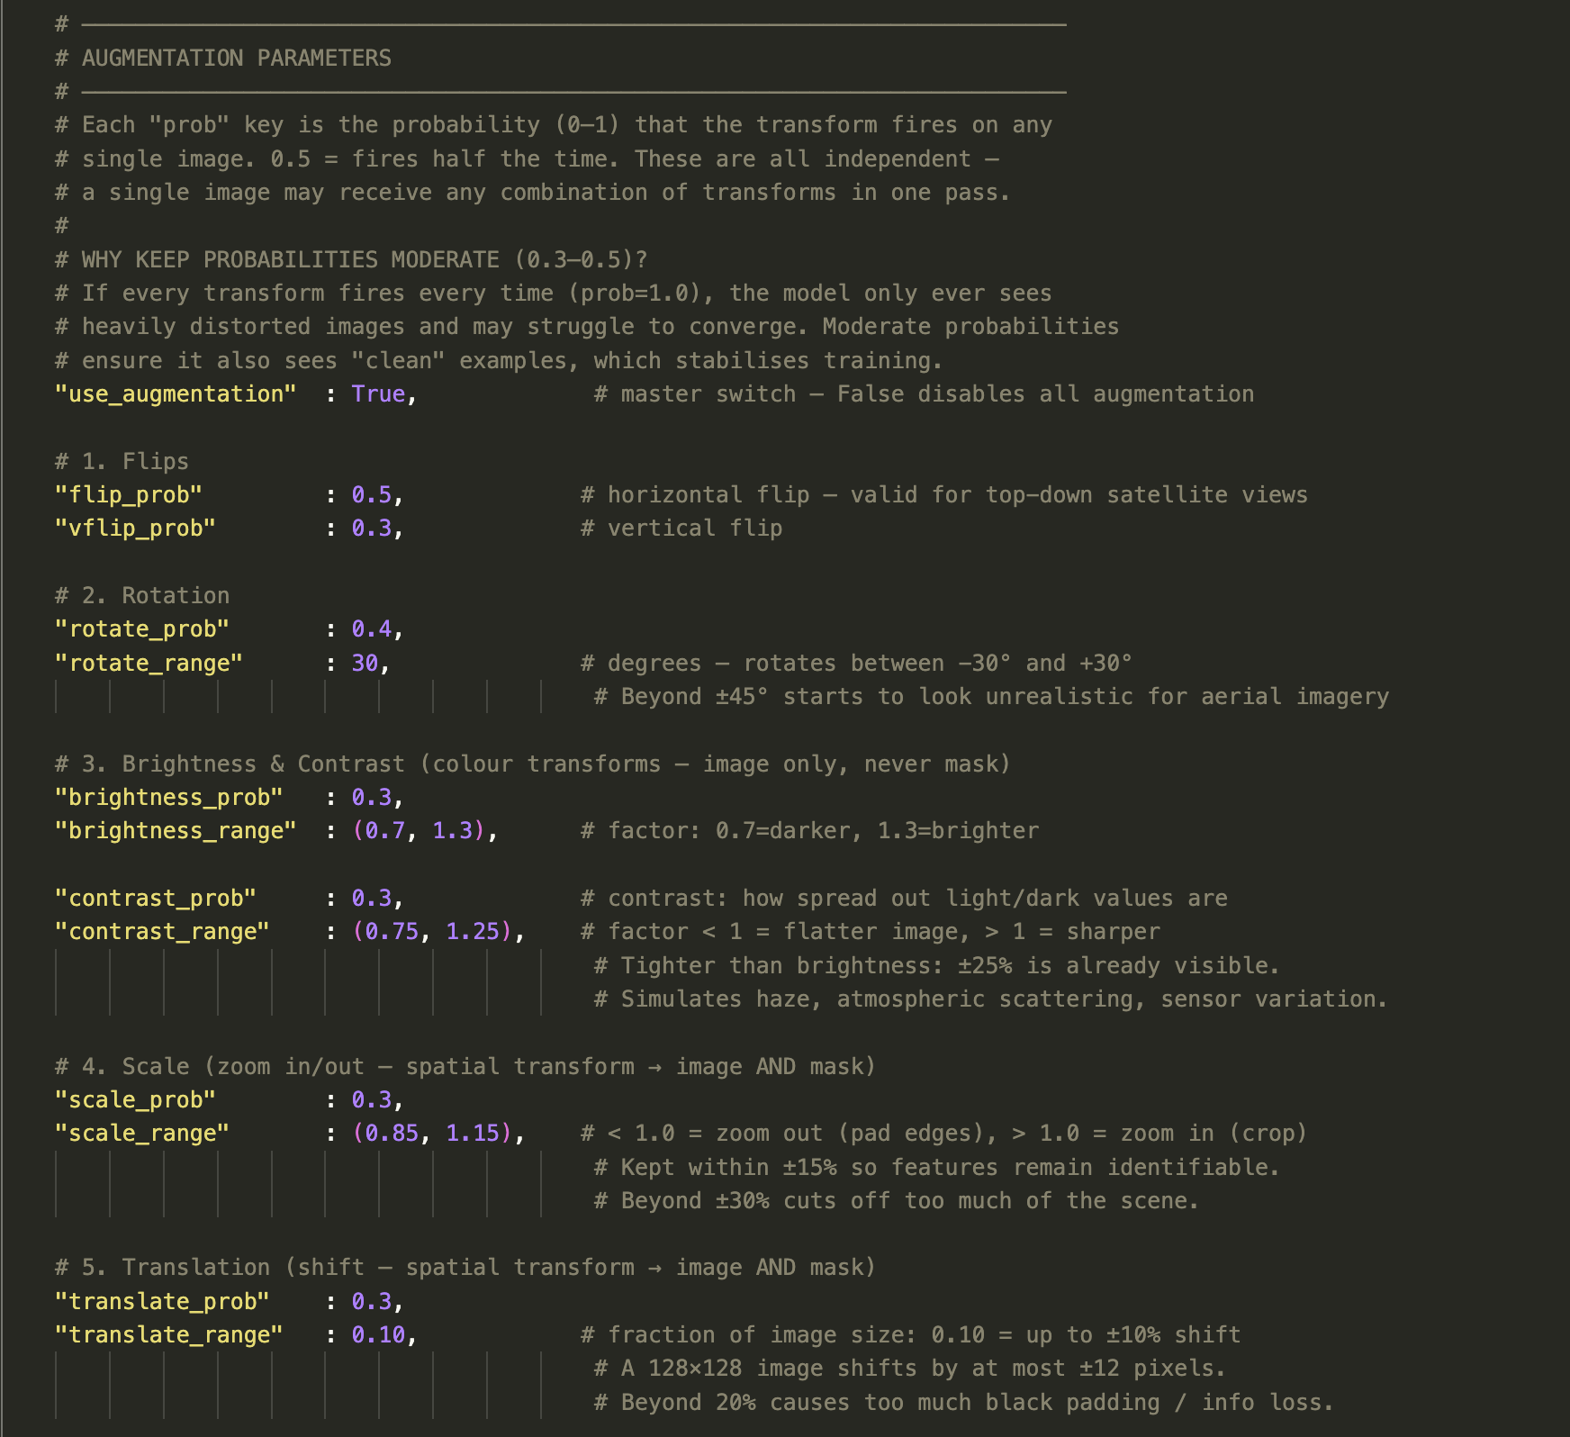

To apply and control the augmentation, we create a class to manage data augmentation.
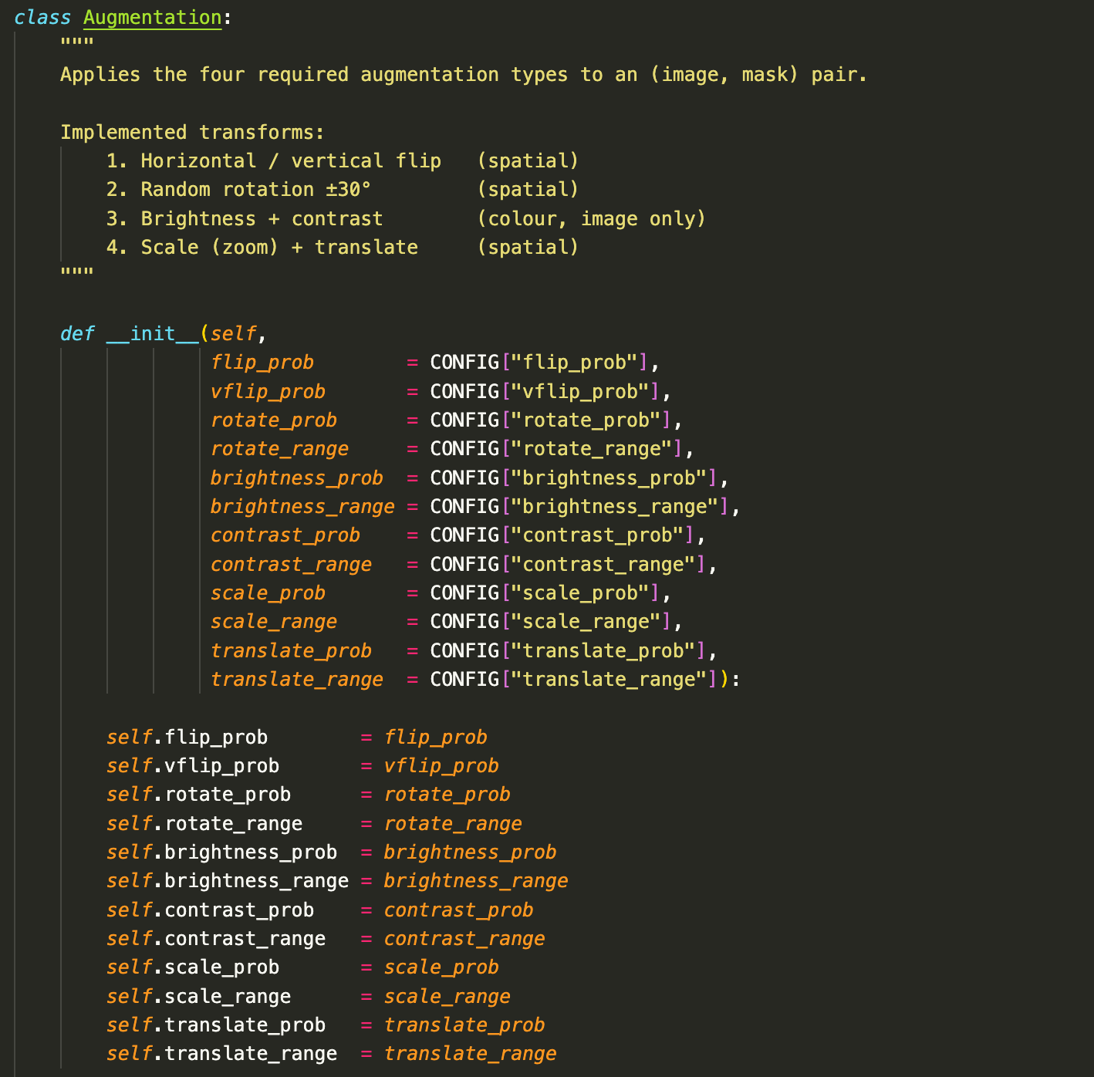

Now, to apply each augmentation into the data, we select a random number, if that number is smaller than our probability, we apply the changes.
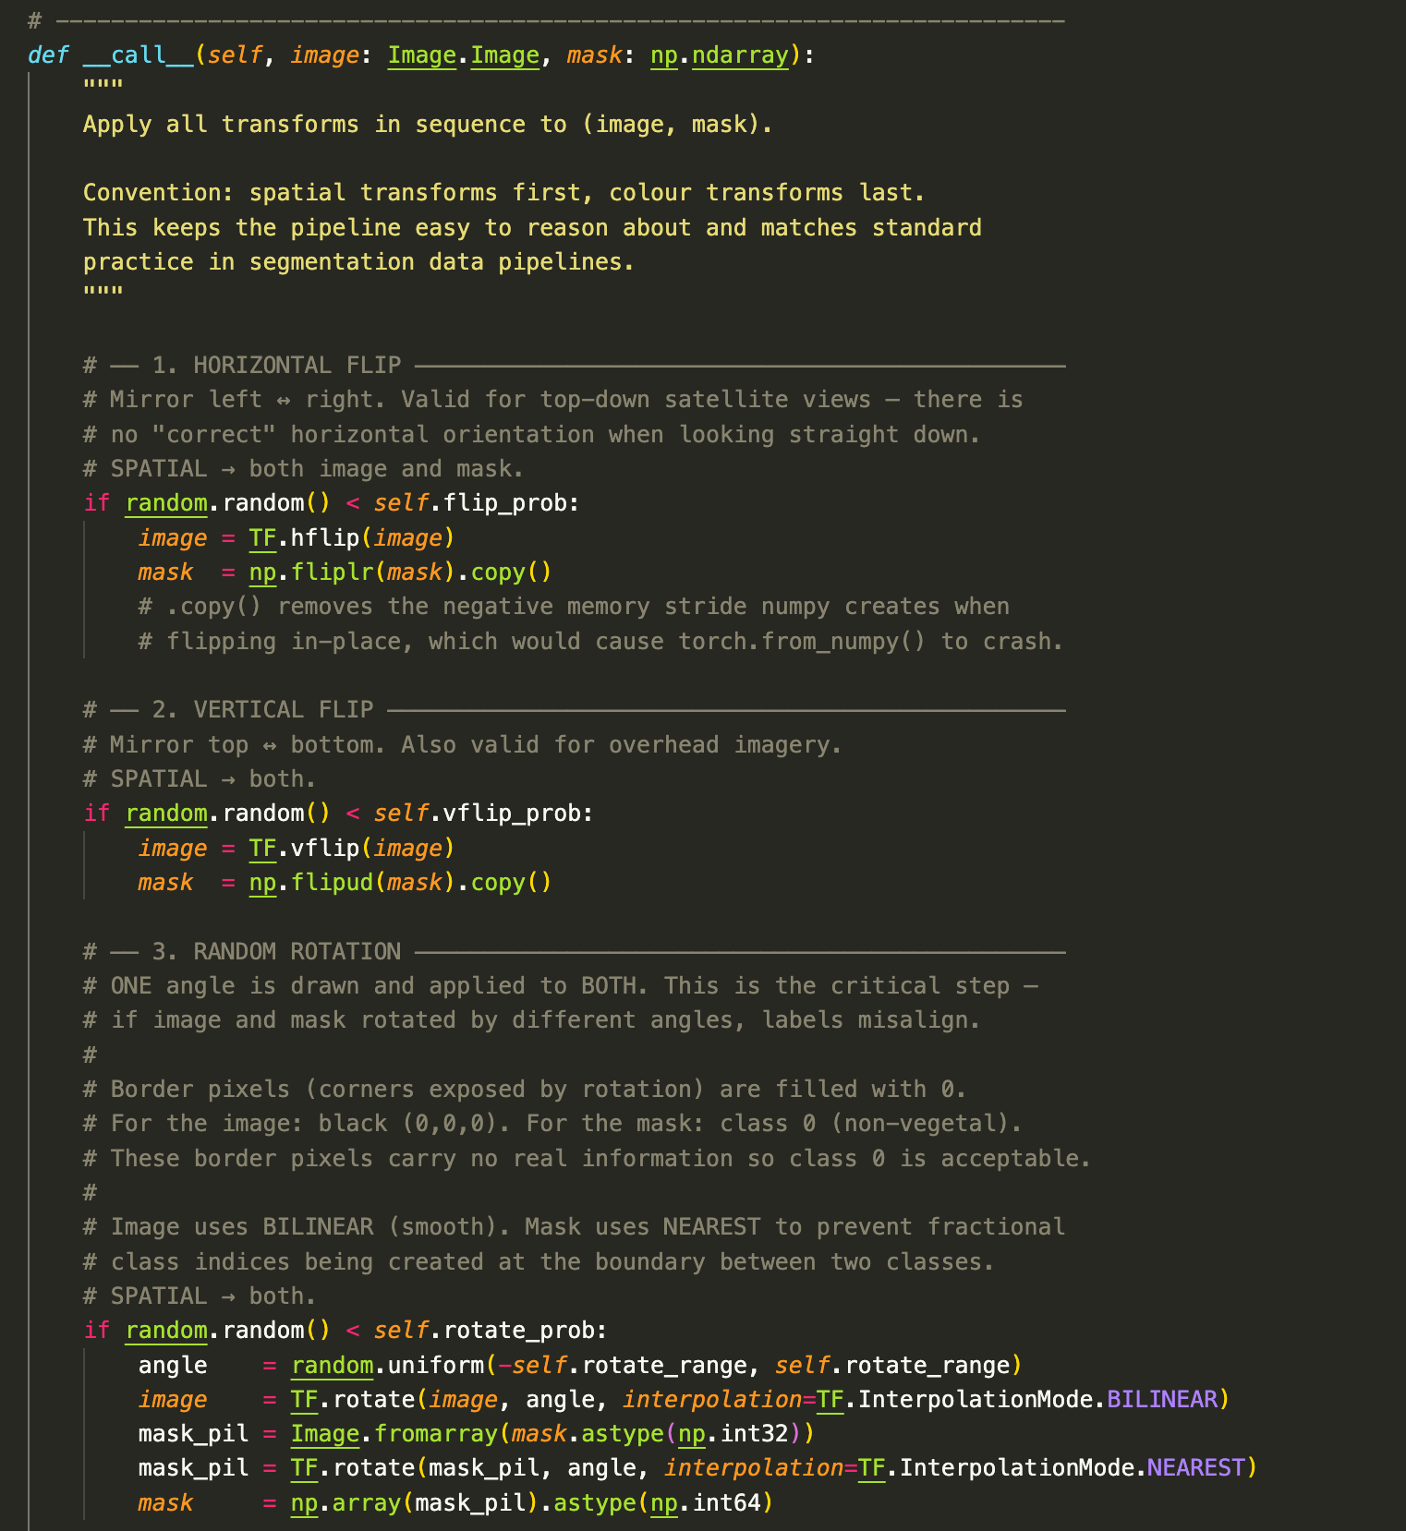
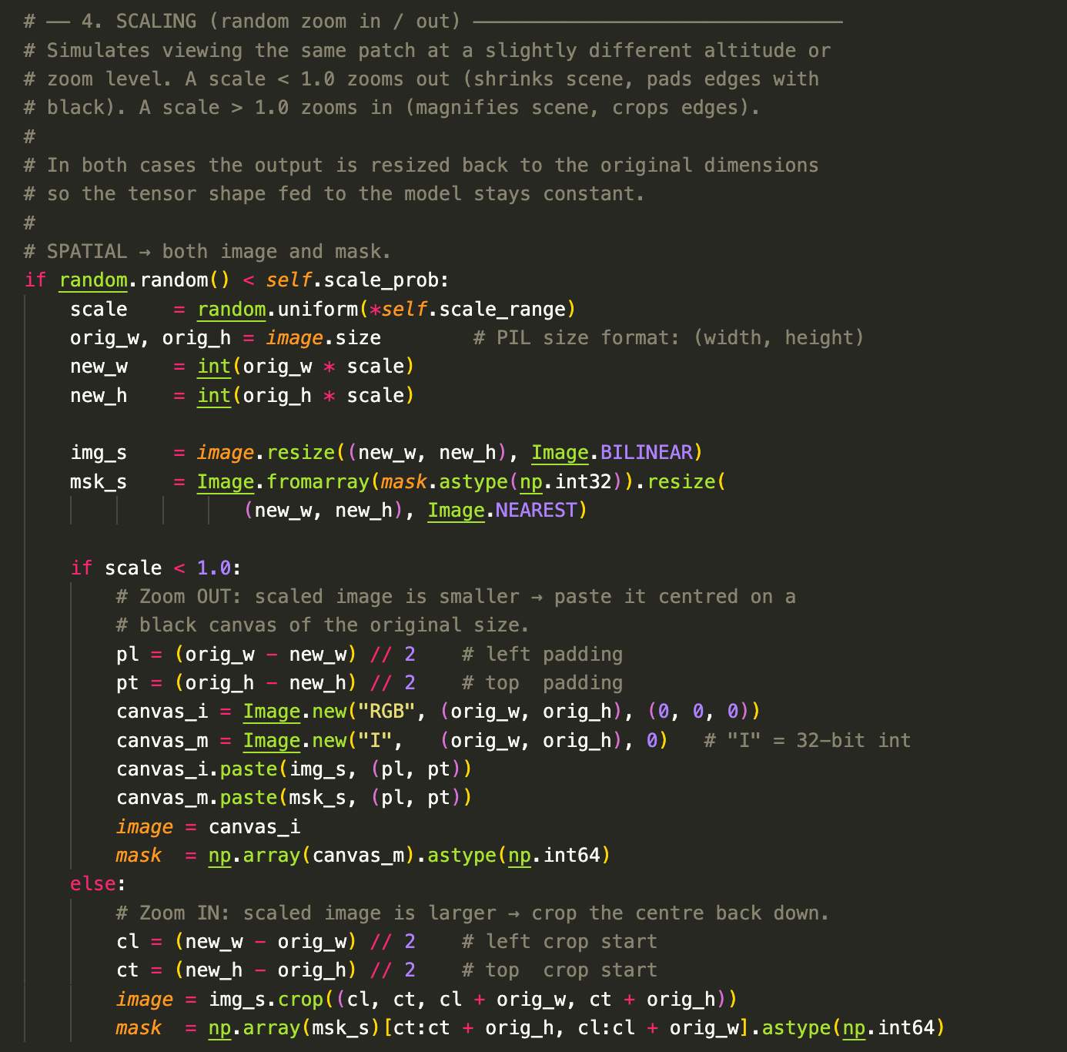
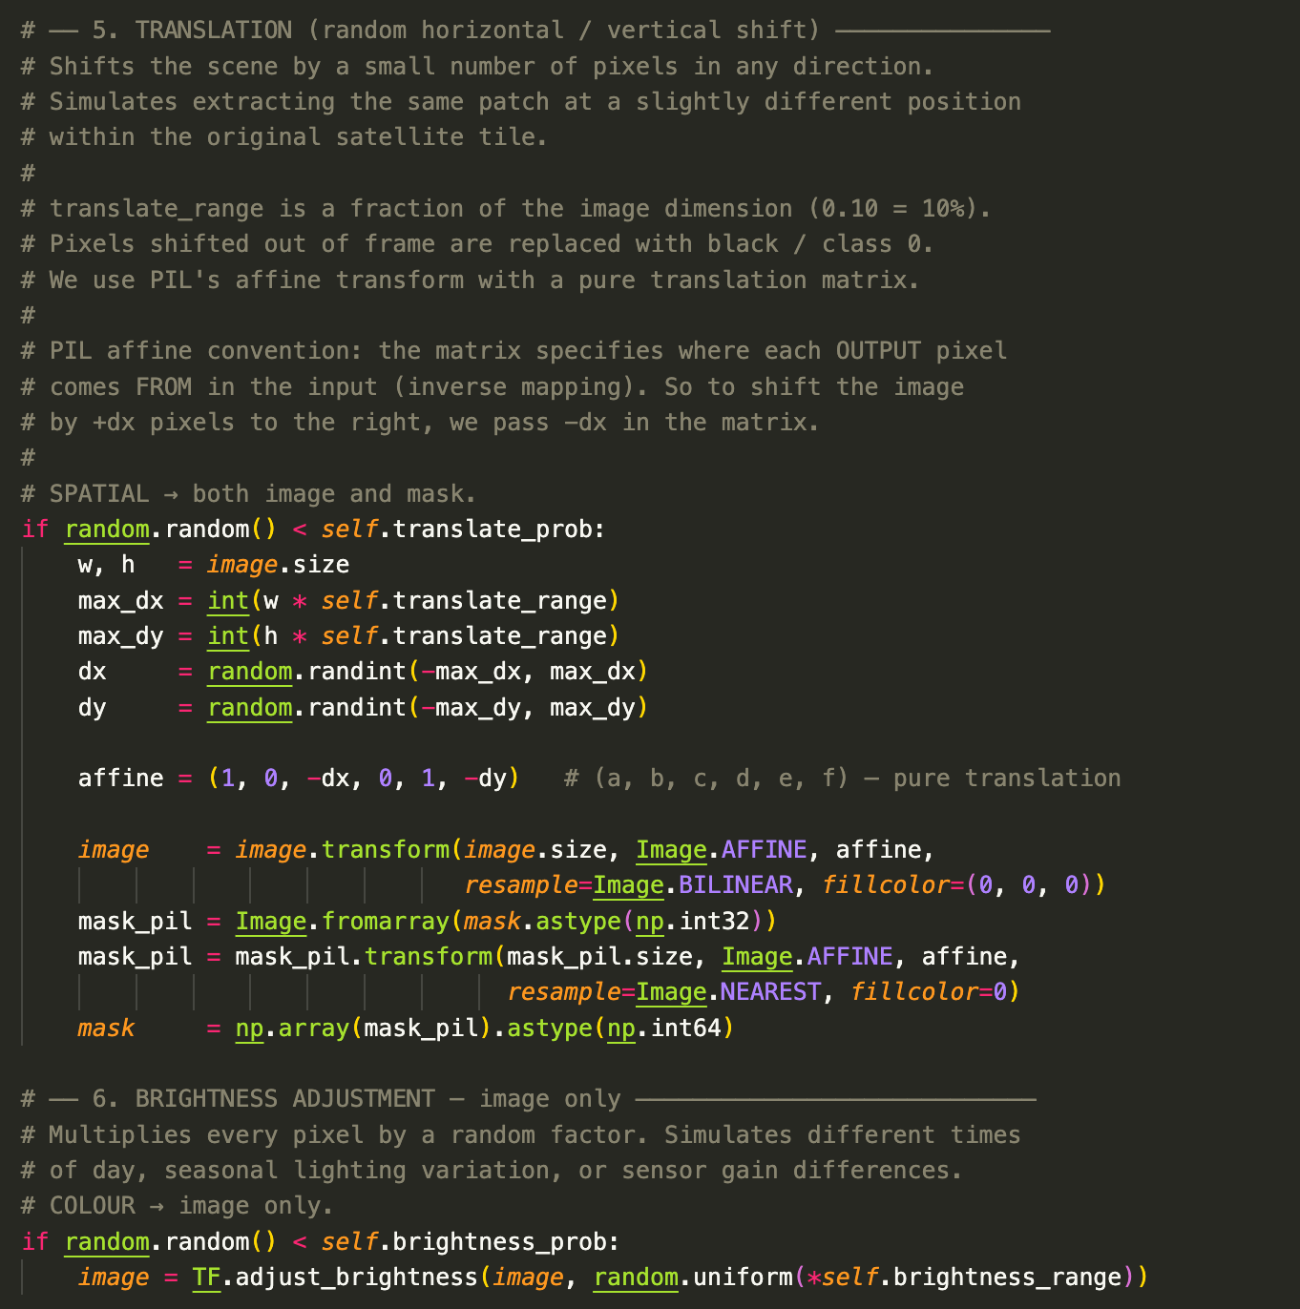
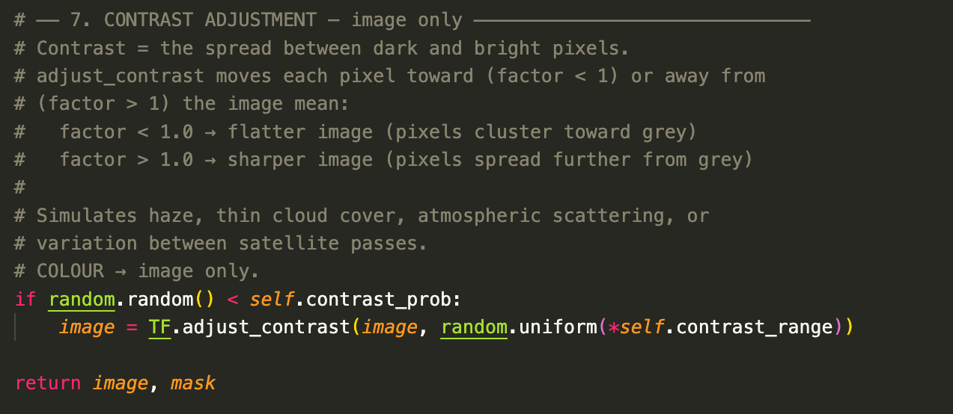

Some examples of data augmentation are:
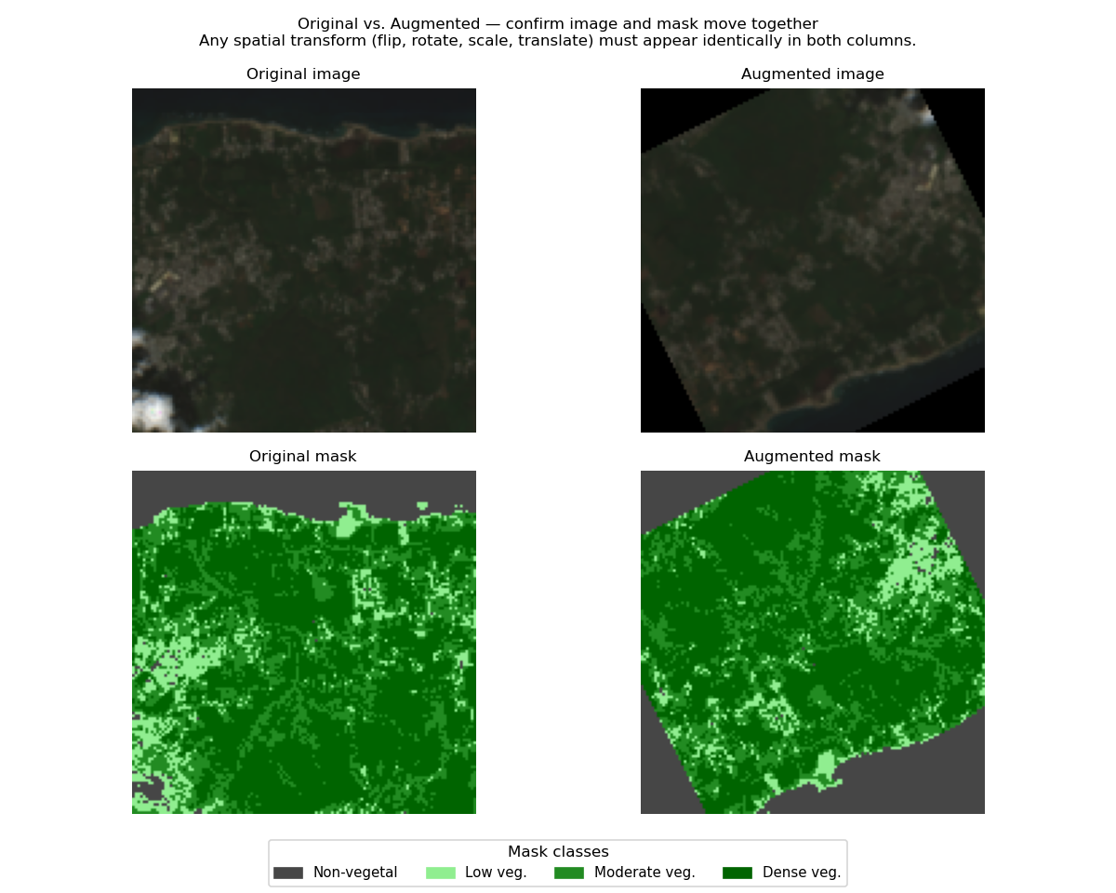
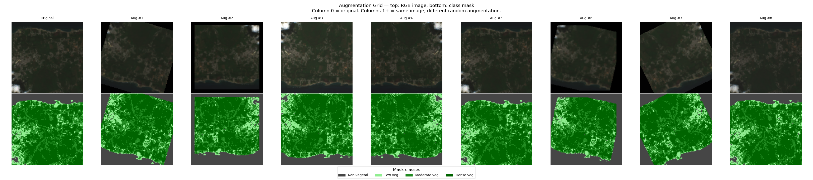

References
[1] “Transforming images, videos, boxes and more — Torchvision 0.26 documentation.” https://docs.pytorch.org/vision/stable/transforms
[2] deeplizard, “Data Augmentation explained,” YouTube. Nov. 22, 2017. [Online]. Available: https://www.youtube.com/watch?v=rfM4DaLTkMs
[3] “Data Augmentation in Image Classification Models” https://medium.com/accredian/increase-the-performance-of-image-classification-models-b466e1ae3101

